AGXPE Meeting Logistics

June 22, 2018

Henning's Supermarket & Community Room

Entrance Closest to the UPS Store

Community Room is inside and up the stairs (2nd Floor)

290 Main St,
Harleysville, PA 19438
(215) 256-9533

Breakfast Buffet is included from 7:30 – 9:30 am

Lunch Buffet is included from 11:30-1:30 pm

Get Mapquest Directions by Clicking on the following links

From Freehold, NJ
http://mapq.st/2tgkwC0

From Morristown, NJ
http://mapq.st/2MdzBuW

From Cherry Hill, NJ
http://mapq.st/2toNkr2

From Trenton, NJ
http://mapq.st/2Ie489F

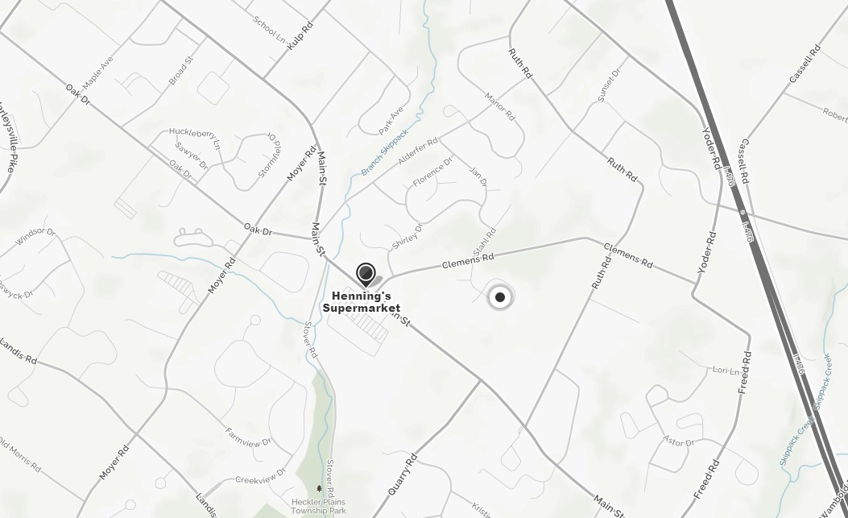

Map of 2 mile radius of meeting

