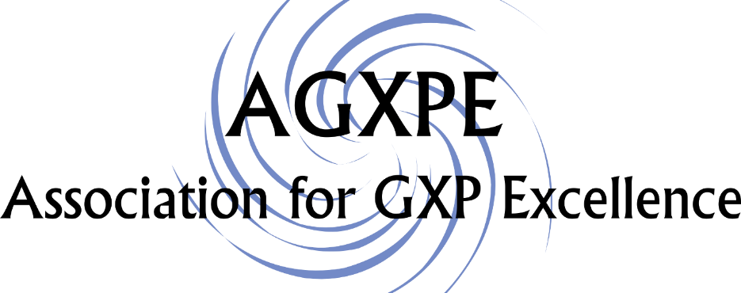

New England Chapter

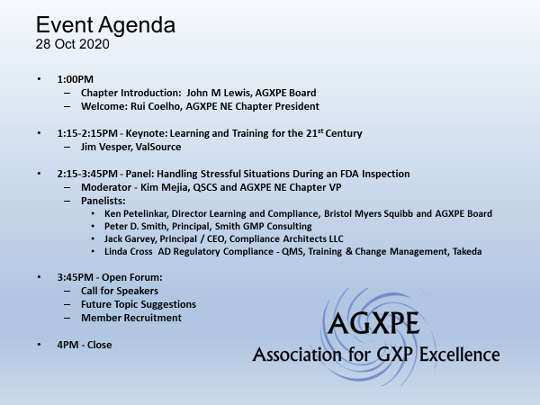

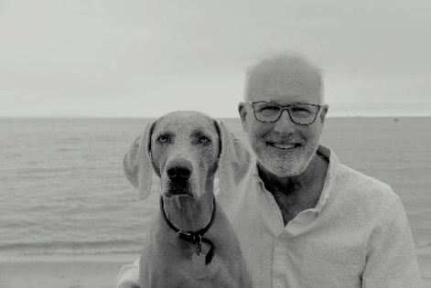
Learning and Training for the 21st Century

Jim Vesper, ValSource

1:15PM-2:15PM

As we begin a new decade, for us in the pharma/biopharma industry what are the learning theories that have the most practical importance and what do we see as ways to develop competencies in our personnel? Does leader-led training still have a role? What about the use of the ‘read and understand’ method? And where do some of the sexy technologies like virtual reality (VR) and augmented reality (AR) fit into the puzzle?

With the challenges that some of us face working remotely but still needing to provide (and receive) training, what are some of the options available to us that today’s technology can provide? How do these approaches align with good practice and what we know about learning and training? Are the sexy tools like virtual reality (VR) and augmented reality (AR) going to solve all our problems?

James Vesper, PhD, MPH, Director of Learning Solutions at ValSource, who has worked with firms around the globe and organizations like the World Health Organization (WHO), will be discussing ways that firms are moving from a training model to one that better supports initial and on-going learning. He is the author of six books and numerous articles on GMP and learning-related topics and has more than 35 years of experience in pharma and biopharma.

Handling Stressful Situations During an FDA Inspection

215PM-3:45PM

Moderator: Kim Mejia, QSCS

Panelists:

Ken Petelinkar, Director Learning and Compliance, Bristol Myers Squibb

Peter D. Smith, Principal, Smith GMP Consulting

Jack Garvey, Principal / CEO, Compliance Architects LLC

Linda Cross AD Regulatory Compliance - QMS, Training & Change Management, Takeda

FDA inspections are stressful because negative consequences can result if the investigator finds deficiencies in that organization’s quality system. In a high-energy, interactive, virtual session, the attendees will be divided into breakout rooms and asked to discuss how they would respond to challenging situations. Then an expert panel will comment on the attendees’ solutions.

Moderator: Kim Mejia is as Quality Management/Compliance Consultant for QSCS. She has 25 years of experience as a regulatory and compliance leader. Her expertise includes team building, creating and overseeing the management of policies and procedures, and working as a subject matter expert in medical device quality and regulatory disciplines.

She holds a Bachelor of Science degree in Biochemistry from Emmanuel College in Boston, MA, magna cum laude and an MBA from Bentley University in Waltham, MA (with distinction). While working at the Massachusetts Institute of Technology, she co-authored an article published in Science on “Genetic Control of Programmed Cell Death in Drosophila.” She served as a panelist at the Regulatory Affairs Professional Society (RAPS), AdvaMed and ASQ meetings on topics ranging from CAPA to effective communication and maintaining composure during FDA inspections. As Vice President of the New England Branch of the Association of GxP Excellence, Kim is delighted the New England branch has been inaugurated.

Panelists:

Ken Petelinkar, Director Learning and Compliance, Bristol Myers Squibb – Ken is a veteran learning and development professional with nearly 25 years’ experience in the pharmaceutical industry leading high-performance teams in R&D, Manufacturing (Clinical and Commercial) and Supply Chain.

He has familiarity with many GXP areas, but has an extensive GMP background. Ken's central learning focus is continuous improvement of skills and knowledge while balancing risk and compliance. Ken is a degreed engineer and has experience from early-phase drug development through commercialization.

Ken is an original founder of the AGXPE. He is the Chairman of the AGXPE Board of Directors and Chief Financial Officer. Ken is an active participant within the L&D, OD, Training, and Quality communities.

Peter D. Smith, Principal, Smith GMP Consulting - formed his own company following retirement from PAREXEL Consulting in April 2018 where he worked for 23+ years in various positions. His last position was Vice President, Technical where he worked with clients in the pharmaceutical and biologics industry worldwide, which continues with his current company.

Mr. Smith joined PAREXEL (then KMI) in 1994 following a 22-year FDA career. At the FDA, he worked in the field and at headquarters as an Investigator, specializing in pharmaceutical GMP/GCP and medical device inspections. His last position at FDA was Associate Director, International and Technical Operations Branch, Division of Field Investigations. In this capacity, he managed the FDA’s Foreign Inspection Program. During his FDA career, he conducted inspections of pharmaceutical plants in the U.S., Europe, Asia, South America and Australia.

Mr. Smith has primary expertise in GMPs for sterile and non-sterile drug dosage forms, active pharmaceutical ingredients, management of inspections, including Pre-approval and foreign inspections, GMP quality systems and FDA regulatory issues. He has experience in antibiotics, radiopharmaceuticals, parenterals, non-clinical (GLP) laboratory studies, and GCP compliance. He works with biologics and pharmaceutical client companies to achieve site facility compliance, implement GMP/Quality System corrective action plans, prepare clients for successful regulatory inspection outcomes, due diligence audits, and conducts GMP audits and assessments. He is a highly experienced public speaker and trainer in GMP and FDA inspection readiness topics.

Mr. Smith holds a BS in Biology from Roger Williams University, Bristol, Rhode Island. He is a member of PDA, ISPE and RAPS, and is an Associate Adjunct Professor at the University of Rhode Island, College of Pharmacy, providing lectures to pharmacy students.

Jack Garvey, Principal / CEO, Compliance Architects LLC

Jack is an accomplished, broad-based FDA quality, regulatory and compliance expert with more than 30 years of experience developing and leading quality, regulatory and compliance initiatives at top FDA-regulated companies. His unique background as a chemical engineer and attorney provides the ability to support complex technical, operational, regulatory and legal issues within FDA-regulated companies.

Using both traditional and proprietary approaches to quality and compliance remediation, he expands upon traditional operational practices with pragmatic solutions that can reduce enforcement risk from today’s aggressive FDA.

As a chemical engineer and attorney by formal training, he possesses the legal, regulatory and process expertise that enables him to excel at problem-solving and solution development across the complex interplay of science, law and business.

Jack will be our guest speaker in January on Handling Virtual Inspections

Linda Cross, A.D. Regulatory Compliance - QMS, Training & Change Management, Takeda Pharmaceutical Compliance and performance development professional with over 13 years of pharmaceutical training and change management knowledge. Experienced in preparation and facilitation of FDA inspections. Passionate about driving organizations toward compliance through cultural and continuous improvement strategies.

Mrs. Cross has worked at Biogen, Sanofi, and Northern Light Health over her career. Her primary expertise in GMPs has focused on training, documentation, and systems project management. She is experienced in multi-site/global management of Quality Management Systems (QMS) and has proven competence in developing Human Performance solutions using Kaizen methodologies.

Mrs. Cross holds a BS in Biomedical Laboratory and Clinical Sciences and a Masters in Administrative Sciences, majoring in Project Management from Boston University. She has served as an Adjunct Science Professor at Middlesex Community College for Special Topics in Biotechnology. She also serves as a STEM speaker in the New England region.

Open Forum:
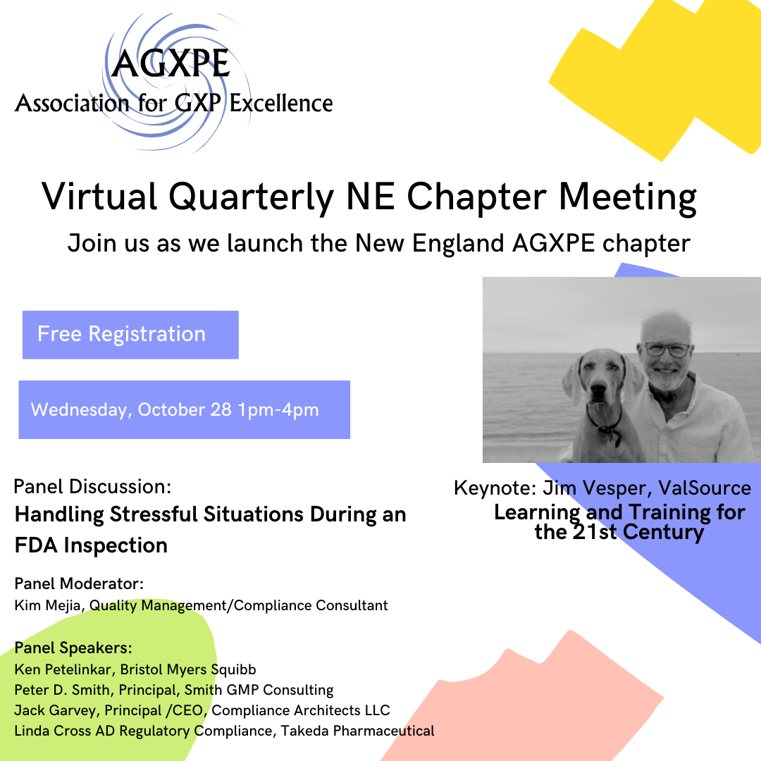

3:45PM-4:00PM

- Call for Speakers
- Future Topic Suggestions
- Member Recruitment
Close:
4:00PM

